**Nama : Fauzan Abdurrahman**

**NPM : 1806065**

**Pengembangan Platform Web**

**Latihan Mengambil Data API**

1. Mengambil API dari <https://api.kawalcorona.com/indonesia/provinsi/>

2. Output

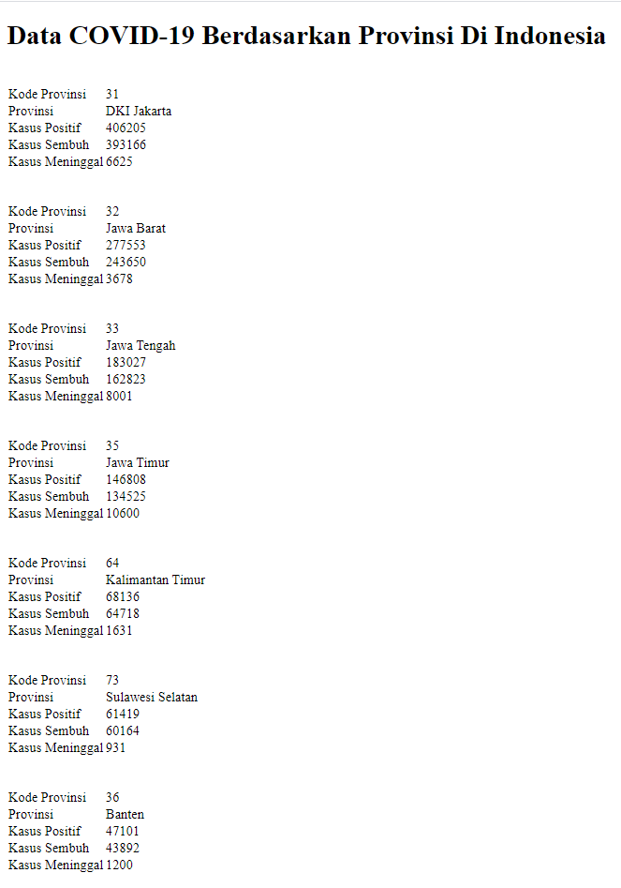

3. Source Code

<?php

function get_CURL($url)

{

$curl = curl_init($url);

curl_setopt($curl, CURLOPT_URL, $url);

curl_setopt($curl, CURLOPT_RETURNTRANSFER, 1);

// mematikan ssl verify (https)

curl_setopt($curl, CURLOPT_SSL_VERIFYHOST, 0);

curl_setopt($curl, CURLOPT_SSL_VERIFYPEER, 0);

$result = curl_exec($curl);

curl_close($curl);

return json_decode($result, true);

}

$result = get_CURL('https://api.kawalcorona.com/indonesia/provinsi/');

// echo "<pre>";

// print_r($result);

// echo "</pre>";

$count = count($result);

?>

<!DOCTYPE html>

<html lang="en">

<head>

<meta charset="UTF-8">

<meta http-equiv="X-UA-Compatible" content="IE=edge">

<meta name="viewport" content="width=device-width, initial-scale=1.0">

<title>Document</title>

</head>

<body>

<h1>Data COVID-19 Berdasarkan Provinsi Di Indonesia</h1>

<?php

for ($i = 0; $i < $count; $i++) {

$data = $result[$i]['attributes'];

?>

<br>

<table>

<tr>

<td>Kode Provinsi</td>

<td><?php echo $data['Kode_Provi'] ?></td>

</tr>

<tr>

<td>Provinsi</td>

<td><?php echo $data['Provinsi'] ?></td>

</tr>

<tr>

<td>Kasus Positif</td>

<td><?php echo $data['Kasus_Posi'] ?></td>

</tr>

<tr>

<td>Kasus Sembuh</td>

<td><?php echo $data['Kasus_Semb'] ?></td>

</tr>

<tr>

<td>Kasus Meninggal</td>

<td><?php echo $data['Kasus_Meni'] ?></td>

</tr>

</table>

<br>

<?php

}

?>

</body>

</html>